Use Case:

User can manage spending or earning by this app. They can type in the date and amount and the details of the spending or earning. The top bar is for the current balance.

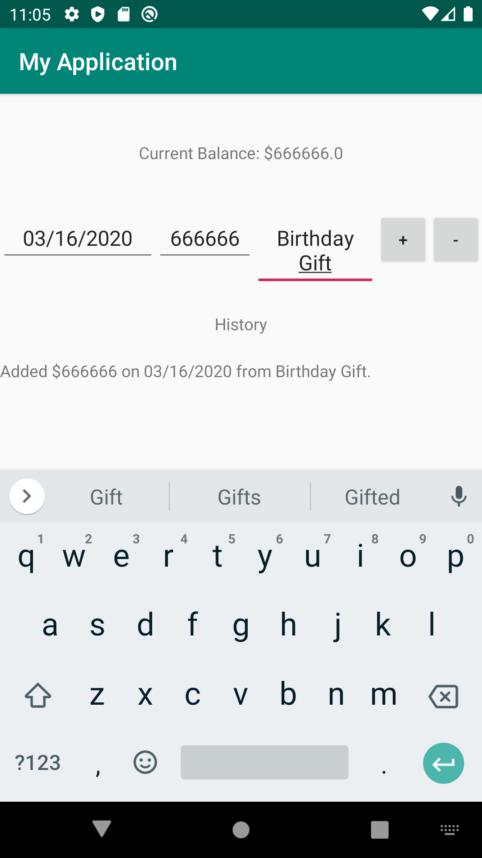

After reopen the app, you can still see the transaction detail history at the bottom of the app.

